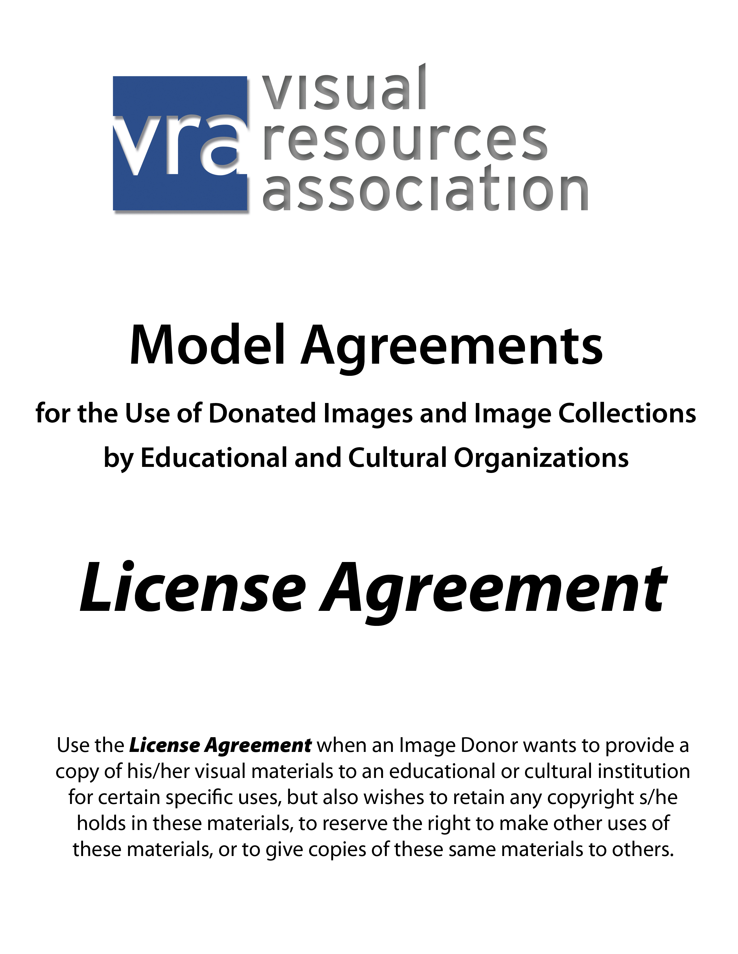

[Insert Name and Address of Recipient Institution]

LICENSE AGREEMENT
[Giving Copy of Visual Materials
With Limited Permissions to Use Those Materials]

I,___________________________, the undersigned provider of the visual materials described below (“Materials), give _________________________ [print name of institution receiving permission] (the “Recipient”) the Materials (or a copy of the Materials), and grant permission to the Recipient to use those Materials as set forth below.

SECTION TO BE COMPLETED BY PROVIDER OF VISUAL MATERIALS:

Description of Materials (including Number and Nature of Materials, any Title Associated with them, When the Materials Were Created, When Materials were Published, if known, and Any Known Copyright Registration Date and Number) (Attach Additional Pages as Needed):
___________________________________________________________________
___________________________________________________________________

Copyright Status in Visual Materials:
To the best of my knowledge, I own the copyright in the Materials or have the right to grant these permissions. (Please check one box.) (Need help answering this question? Click here or go to
http://www.vraweb.org/resources/ipr/dirc/principles_def.html):

Yes _______ No ________

People or Works Depicted in the Materials:
I obtained permissions from the creator or copyright owner of any work depicted in the Materials, or I obtained permissions from any person depicted in the Materials, to incorporate an image of that work or person in the materials (e.g., I obtained permission from the sculptor when I photographed his or her sculpture). (Please check one box, even if no permissions were needed. Check “no” if not applicable):

Yes _______ No ________

If I obtained such permissions, I have described those permissions below (including their scope, any limitations, and how those individuals or entities might be contacted). (Attach copies of any written permissions):
___________________________________________________________________
___________________________________________________________________

Limitations On Use of Materials: To the extent that I hold the copyright in the Materials, I am indicating any limitations on the uses Recipient may make of the Materials. (Note: These limitations shall only apply if the provider owns a copyright in the Materials, or is a representative of the copyright owner, and any limitations will only apply while the Materials are under copyright.) (If no limitations are listed, there are no restrictions):
___________________________________________________________________
___________________________________________________________________

Suggested Attribution or Credit Line: (Please note that you must be a copyright
owner in the Materials, or the copyright owner’s representative, to have a copyright
credit line):
___________________________________________________________________

OTHER TERMS OF LICENSE AGREEMENT:

1. Copyrights in the Materials: Unless I have expressly indicated otherwise above, I represent and warrant that: (a) to the best of my knowledge, I own the copyright(s), and have the authority to grant the licenses herein with respect to, the Materials; (b) I have not previously transferred my copyrights in the Materials; and (c) if in the future I transfer my copyrights in the Materials, such transfer will be subject to these licenses (and any agreement to the contrary shall be automatically void to the extent that it conflicts with these licenses).

2. Objects and Persons Depicted in the Materials: Unless I have expressly indicated otherwise above, I make no representation that I obtained permissions from others to reproduce any works, or incorporate the likeness of any persons, in the Materials.

3. License in Materials and Transfer of Ownership in Physical Copy of Materials: I hereby transfer to the Recipient ownership in the copy of the Materials I am providing to the Recipient, which the Recipient may use in accordance with this Agreement. With respect to my copyright(s) in the Materials, I grant the Recipient a non-exclusive, perpetual, irrevocable, worldwide, and free of charge or royalty, transferable license to reproduce, distribute, publicly display, and publicly perform (to the extent applicable) the Materials, to make derivative works of the Materials, and to reproduce, distribute, publicly display and publicly perform such derivative works, subject to any restrictions indicated above. I grant this license with respect to any resolution, format and medium of the Materials, whether now known or hereafter developed. Nothing in this Agreement obligates the Recipient to exercise this license, and the location, retention, cataloging, and preservation of the Materials, or other aspects of their disposition, are at the discretion of the Recipient.

4. Limitation on Liability: I am providing the Materials to the Recipient with the understanding that I will not be liable for any use of the Materials made by the Recipient (or by others the Recipient authorizes to use the Materials), provided that I have accurately completed the questions in this Agreement to the best of my knowledge.

5. Fair Use and Other Exceptions: Nothing in this Agreement is intended to limit or restrict any uses that are free from copyright or any rights arising from any limitations or exceptions to copyright (such as the United States doctrine of fair use or the Canadian doctrine of fair dealing).

6. Other: This License Agreement is the only agreement and supersedes all other understandings between the signatories below (the “Parties”) regarding the Materials, and shall not be modified except by written agreement signed by the Parties. This License Agreement shall be governed by the federal, state or provincial laws, and venue shall lie exclusively in the courts of the state or province, in which the principal offices of the Recipient are located.

The Parties have read, understood and accepted the terms of this License Agreement.

PROVIDER OF VISUAL MATERIALS:
Printed Name: _______________________________________________
Signature: ___________________________________________________
Contact Information: __________________________________________
____________________________________________________________
Date: _______________________________________________________

RECIPIENT:
Printed Name: _______________________________________________
Signature: ___________________________________________________
Title: _______________________________________________________
Date: ______________________________________________________________

DISCLAIMER: THIS MODEL LICENSE AGREEMENT WAS CREATED BY THE VISUAL RESOURCES ASSOCIATION TO FACILITATE THE SHARING OF VISUAL MATERIALS. THE DISTRIBUTION OF THIS LICENSE AGREEMENT DOES NOT CONSTITUTE LEGAL ADVICE, AND DOES NOT ADDRESS EVERY FACTUAL SITUATION THAT MIGHT ARISE THROUGH AN AGREEMENT LIKE THIS ONE. THIS DOCUMENT IS PROVIDED ON AN “AS IS” BASIS AND THE VISUAL RESOURCES ASSOCIATION MAKES NO WARRANTIES OF ANY KIND, INCLUDING WITHOUT LIMITATION WARRANTIES OF MERCHANTIBILITY OR FITNESS, WITH RESPECT TO THIS DOCUMENT. YOU SHOULD REVIEW THIS DOCUMENT WITH YOUR INSTITUTIONAL COUNSEL AND OBTAIN ALL NECESSARY LEGAL ADVICE BEFORE USING THIS DOCUMENT.

Need Help Answering this Question? A creator who creates works that are at least minimally original and creative automatically owns the copyrights in such works upon their creation. The creator does not have to do anything else to hold a copyright in that creation. A person or entity may also obtain the copyright in works created by others, when those works are inherited through a will, or when they are acquired through a contract, for example. Or a person or entity may not own the copyright, but may have been given permission by the copyright owner to act on his or her behalf in allowing others to use the materials. A person will not own a copyright in visual materials where there is no creativity or originality inherent in creating the materials – for example, if you copied someone else’s photograph using a scanner, you will not own the copyright in that scanned image. Note that there may be more than one copyright owner in visual materials. If you photographed a sculpture, for example, you own the copyright in the photograph. But the creator of the sculpture – which is now depicted in the photograph – typically owns the copyright in the sculpture. This question is only asking about what rights you may own in these visual materials. (In a subsequent question, you are asked about known copyright holders in any objects depicted in the visual materials). More information about copyright can be found on the VRA website, at http://www.vraweb.org/resources/ipr/dirc/index.html.

